CP2406

Programming 3

Task 1

Keashyn Naidoo

**User Stories:**

User Story 1:

As for the user I want to develop the traffic simulator for customisation so that I can edit the road, car, traffic light and length, breath, width of roads. The priority is high and estimated day is 4 days. For the testing develop the new city maps, add street names and run the simulation.

User Story 2:

As for the user I want to keep developing the city to use again later so that I can make sure that the customised city does not disappear with the changes. The priority is medium and estimate time is 3 days. For testing, after the changing the city press the save button to save the city with any name that the user want name it.

User Story 3:

As for the user I want to reload the previous developed city and to load it into the simulation so that I can run the simulating again with different situation like cars, buses, motorbikes and rates. The priority is low and estimated time is 2 days. For testing it is press on the open button to accessed the saved city from the database.

User Story 4:

As for the user update the vehicles rate so that it can run in the simulation so that I can control how many vehicles can be on the road. The priority is medium and estimated times is 3 days. For testing click the update vehicle rate button to make all the vehicles move faster or slower.

User Story 5:

As for the user I want to have a stop button to stop the simulator so that the moving vehicles on the roads so that the simulator running process is terminate. The priority is high and estimate time is 1 day. For the testing press the stop button and watch all the vehicles being terminate.

User Story 6:

As for the user I want to avoid collision with the other vehicles based on the distance from ahead vehicles so that I can run the simulator without any errors or problems I might’s face when the simulator is running. The priority is high and estimate time is 5 days. For the testing checking to see if the simulator runs and to see if there are no collision with vehicles when the program is running.

## **Developer User Stories:**

Developer User story 1:

As developer I can add to change the light and traffic for the user. There are bus and motorbike for this car simulator. The priority is high and estimate time is 3 days. For the testing, abstract the vehicles class and call some methods to move the cars.

Developer User Story 2:

As developers can also stop the cars traffic to avoid collision with in front of car, there will be no error at all. The priority is low and estimate time is 2 days. As for the testing: get the distance from the front of vehicles and call some methods from vehicles.

Developer User story 3:

As developer make the program to save all of the data that can’t occur data missing to customers. The priority is high and estimate time is 3 days. For the testing, save the all data as a file at main method and load the data to view the map again.

Developer User story 4:

As for the developer, I want to load some of all data that was created from the user so that all data can load and run again after program started. The priority is medium and estimate time is 1 day. For the testing, at main method, read the data file from the specific path and load the data into the traffic simulator.

ULM Diagram:

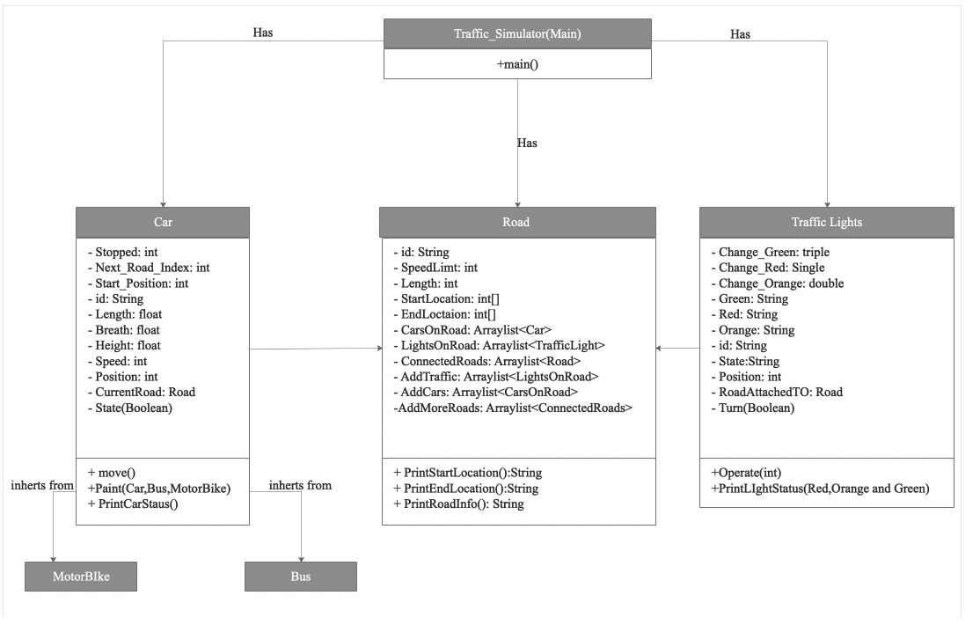

GitHub:

<https://github.com/Keashyn/CP2406-Assignment-1-Traffic-Simulator-1.0-Keashyn-Naidoo>

